PYTHOGRAPHY: Python based Personalized Learning Management and Tutorial System for Programming Introduction

1st Jose Rafael Barnuevo   
*Electronics and Communications Engineering Department*  
*De La Salle University*Manila, Philippines  
jose_rafael_barnuevo@dlsu.edu.ph

2nd Margarita Bautista  
*Electronics and Communications Engineering Department  
De La Salle University*Manila, Philippines  
marga_bautista@dlsu.edu.ph

3rd Joshua Emmanuel Torre  
*Electronics and Communications Engineering Department*  
*De La Salle University*Manila, Philippines  
joshua_emmanuel_torre@dlsu.edu.ph

*Abstract*—Pythography is a Python based Personalized Learning Management and Tutorial System for Programming introduction program created using Tkinter. It aims to develop a computer program that integrates personalized learning and teaching Python programming. Through this, students will be able to learn in a manner that is more appropriate for their current level of understanding of the topic since appropriate modules will be given to the users depending on their assessed level (beginner, intermediate, and expert). The modules will consist of the discussion of the topic followed by a question in order to test the understanding of the user.

Keywords—Personalized Learning, Python Programming, Tkinter

# Introduction

Personalized learning is a technique in educating students that is centered around the foundation, needs, potential, and perception of the learner. It is a learner-centered education. On this type of learning system, the goal of the educator is not focused in broadcasting information but to work closely with the students to make sure that they have understood and are able to move their learning on to the next stage[1].

Python, on the other hand, is a high-level programming language, widely used both for work and personal purposes. Many of the web and mobile applications that people use today are products of Python’s rich libraries, various frameworks, vast collection of modules, and file extensions. Learning this programming language is a must for many reasons. This programming language is used in data science, machine learning, web development, automation, and more. Other reasons why a lot of people choose Python as their core language is because of its simplicity, huge community, libraries and frameworks, being multipurpose, job opportunities, and big salary offers[2].

Incorporating personalized learning to teaching programming, with Python as language, is an efficient technique. Programming is not just about learning all the syntaxes, but more on understanding the problem, formulating a solution, and applying the concepts learned from the programming language to provide a concrete solution.

# Significance of the Study

The program will be able to help students learn in a manner that is more appropriate for their current level of understanding of the topic. They will be able to learn at their own pace leading the student to have a deeper understanding of the different lessons on programming using the Python programming language. Since the target users for this project are the Senior High School students especially those who will be taking computer-related courses in College, this would be advantageous since they would be able to use their acquired knowledge in their College courses. This would also be beneficial to Senior High School students taking a non-STEM strand but plan to take computer-related courses as this would prepare them for College. Aside from the target users, which are the Senior High School students, this program can also be helpful for students taking up Python programming classes since some students may have difficulty in coping up in traditional classroom sessions. The students can use this program to serve as an aid and supplement to the discussed lessons in class.

# Objectives

By utilizing the project of the programmers to test the programming skills and knowledge of SHS students, the programmers aim to:

1. To investigate the number of students who are ready for computer-related course.
2. To be able to design and develop a Python based Personalized Learning Management and Tutorial System for Programming introduction.
3. To be able to apply all topics and modules covered by the LBYCPA1 syllabus.
4. To be able to satisfy the minimum requirement for System Usability Scale (SUS).

# Scope and Delimitations

The project will be implemented in De La Salle University, Manila. The project would tackle different topics in Python programming based on the classification of the user (beginner, intermediate, or expert). The limitation of this project involves the project being time-bounded and the materials being limited to laptops. The evaluation of the program will also be conducted only by Senior High School students.

# REVIEW OF RELATED LITERATURE

*Personalized Learning*

The regular classroom classes aim to produce uniformity in the results of the students, which is achieving high proficiency however in reality, test scores are not uniform. Students are unique and are not uniform. Each one has his or her own personal interest and achievements that cannot be compared one student against another. A standardized approach of teaching does not affect all students in the same way. Growth is restricted when the same results are demanded for all students. Diversity should be celebrated. Individual interests, hopes, and talents should be converted to distinctive strengths [3].

As stated in [4], it is necessary to determine the important and relevant information about the student such as the level of comprehension, familiarity of using a platform tool, style of studying, and many more to establish an adaptive course. It is important to continuously take note of the student profile and update it if necessary during the learning process. It should also take into account the progress the student makes; the duration of time being spent on a particular question or learning item; the result of the test; and the rank of satisfaction by utilizing the platform. With this being said, the researchers of the study agreed to have a module that is capable of collecting and interpreting the information gained in the period of learning experience. It was also stated that the design and integration system of tracking the student profile is the authors’ future research objectives.

Given these data, personalized learning is recommended. Personalized learning is a blended approach which combines within and beyond the traditional classroom environment[3]. It has been suggested to originate from Howard Gardners theory of multiple intelligences. It is geared towards the individual interests, needs, and abilities of students as well as the identification of the best learning style for each student. Personalized learning spaces, resources and environments can be developed, supported and created by systematic design that includes the perspective of the instructor as well as the learner[5].

The core four elements of personalized learning includes flexible and content tools, targeted instruction, student reflection and ownership, and data driven decisions. For flexible and content tools, the instructional materials should allow differentiated path, pace, and performance tasks. For targeted instruction, the specific needs and learning goals of students should be taken into consideration in teaching. Small group, 1-1, strategy group, or other targeted instruction can be done to address the specific needs for learning of all students. For student reflection and ownership, the reflections of the students on what they learned will encourage them to improve more and opportunities to make authentic choices as well as ownership for their learning. For data driven decisions, data should be used in order to identify proper instructional methods as well as for students to know their current level of understanding of the topics leading to making learning decisions [6].

*Integration of Technology and Personalized Learning in Teaching Programming*

According to [7], programming is said to be one of the pillars of computing in the computer-related courses and the engineering disciplines. Quoting the description of Deek and McHugh “computer programming is described as a problem solving process of formulating, planning, and designing the solution, translating, testing, and delivery.” For a person to further improve his or her programming skills, one should know how to understand the concept of the language, compose new programs, debug, and integrate existing programs. There are studies that promote teaching programming courses through personalized learning.

There are studies that state that a barrier of implementing personalized learning includes having total dependence on software however the right type of software can support personalized learning however this should be facilitated through a developmental process of blended learning (both class and web based)[5]. This is agreed by a study that stated digital content and tools just work alongside the teacher but do not replace them in order to better support students’ needs through providing remediation, practice, extension, and/or a variety of ways to demonstrate knowledge authentically [6].

Despite these, there are still studies that support e-learning and integration of technology and personalized learning in teaching programming. An example of which is the study by [8] a lot of researchers focused their studies on new techniques in approaching personalized e-learning. There should be a new flexible approach upon the demands for improvements later or applications with the latest strategies. The author and his team came up with a model for personalized learning. The design is composed of an information model and a process model. The model is capable of adapting the strategy and strategy combination. There are various strategies from different studies that can be traced and inserted into the model. The model designed the strategy for creating a program for any computer-related courses and provided a personalized service. This personalized service is suitable for any changes in strategy, not only to a rule’s change, but also in changing the whole strategy plan. A study by [9] agrees to this. It presented a study on an innovative personalized e-learning environment aiming for the student’s understanding on the topic Basic Computer Programming with undergraduate students as test subjects. There are three origins of personalized information such as personalized learning problems, personalized learning styles, and personalized learning achievement. These origins are used to find the personalized subject materials on the topic. The newly improved e-learning environment is capable of an online learning system by providing personal guidance and necessary learning materials to the test subjects or students based on their performance in online learning. The authors investigated the execution of the newly improved e-learning environment with 23 undergraduate students. They discovered that the e-learning environment is capable of helping any users to broaden the knowledge on the topic and they are looking forward to the positive results of the e-learning environment. The overall success of the authors’ study is important in developing the effectiveness of the whole e-learning environment.

In addition, computer programming is complex by nature. Classes in programming may have students with mixed abilities leading for slow students to have difficulty with the pace of their teachers leading to failure in learning the necessary programming skills. A personalized learning environment with customized content and relevant feedback for low, average, and high level students was implemented. With this, students can progress at their own pace. The methodology used was a pre-test that covers key components of programming. Through this, the students’ difficulty in learning programming will be identified. Codeigniter 3 and MySQL database were used to develop the platform. The exponential moving average was used to monitor the progress of the students then take remedial actions. The result showed improvements in the posttest as well as summative assessment. This created positive impacts with regards to progress and perception on all students [10].

Another approach was stated in [11]. It discussed the usage of agents in designing and developing educational tools. Some of the agents that can be used are the Zestful and Provoking agents. These agents aim to increase the learner’s quality of learning. Hints are offered in the Zestful agent which, in the usual methodology of teaching programming languages, represent useful directions for problem solving as propositions of appropriate solutions to the given problem. An example of this would be: for (int i = 0; i < 10; ?){} – “Should you use ++i or i++ to modify the value of i? Remember that this modification is always executed at the end of the for loop.” On the other hand, the provoking agent offers wrong parts of the code through offering false hints and bad solutions to boost the critical thinking of the student in order to decide on the proper solution to the problem. An example of this would be: for (int i = 0; i < 10; ?){} – “Should you use ++i or i++ to modify the value of i? Remember that ++i first increases the value of i, and then uses the new value in an expression.”

*Python Programming*

In an article made by [12] programs were improved in a "self centric" way wherein they are designed to be self contained units with the purpose of giving solution to a specific problem to accomplish a task. There are some programs that are made to be extended by inserting new modules that digest new computational methods within the program's framework for instance, AVS. This can raise some concerns or problems knowing that programs are inherently specialized. To solve this type of problem, the authors conducted a "language centric" approach experiment. They used a high-level language as the core of their framework. Instead of writing programs, the authors improved the language with modules or components that can implement a specific functionality. The high-level language is like a bond that links the modules and components together to immediately construct specialized applications. In other words, the language is a "scripting framework" that provides a rapid design of new applications. Improving the extension modules for the language is equivalent to holding specialization of code as much as possible. The authors believed that an interpreted language would give them the flexibility, interactivity,and extensibility that are necessary for such an approach and they started to discover the top three popular interpreted languages like the Pearl, TCL, and Python. After exploring these interpreted language, the authors agreed to use Python because it is concise and almost pseudocode-like syntax; it is based on a module; its object oriented design; its profiling, debugging, reflection, introspection and self documentation capabilities; and the availability of a Numeric extension allowing efficient storage and manipulation of large amounts of numerical data. This interpreted language is as good as a bond as any other interpreted language; however it can be used to establish substantial extension components.

# Program overview and flowchart

##### 

Fig.1 Input-Process-Output-Chart for Assessment

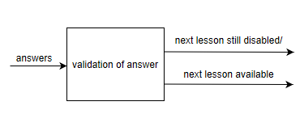

Fig.2 Input-Process-Output-Chart for the beginner, intermediate, and expert modules

The program, Pythography will first determine the level of knowledge that the user is currently in with regards to Python Programming through answering a series of questions. With this, the input for the assessment will be the answers of the user to the questions. The process will be the assessment of the answers while the output will be the remarks showing the user if his or her level is beginner, intermediate, or expert. Through this, the program will be able to create an environment of personalized learning since the correct modules will be given to the user based on his or her assessed level. For all the modules (beginner, intermediate, and expert), Python Programming lessons will be discussed then there will be questions regarding the topic that the user should answer. With this, the answers of the user will be the input. The process will be the validation of the answer. If the answer is correct, the output will be the availability of the next lesson while if the answer is wrong, the next lesson button will remain to be disabled and the user can continue to attempt to enter his or her answers.

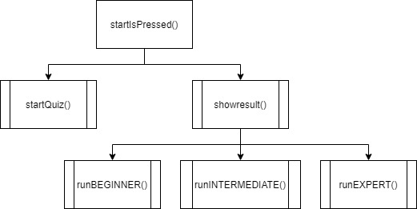

Fig. 3 Hierarchy Chart part 1

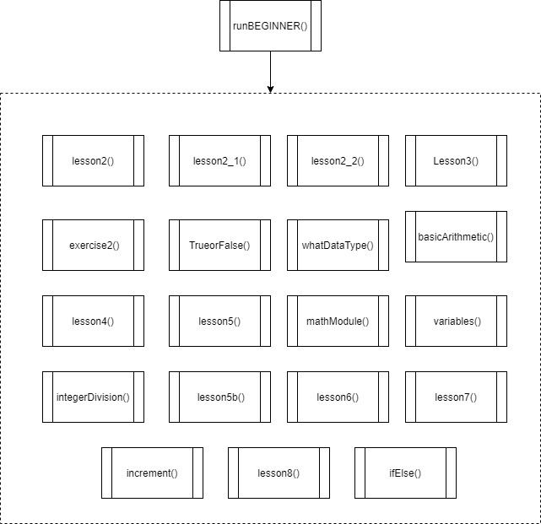

Fig. 4 Hierarchy Chart part 2

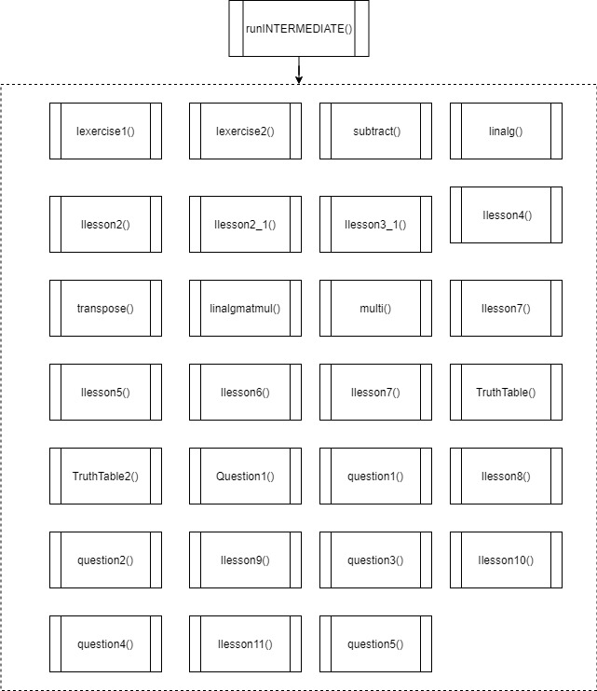

Fig. 5 Hierarchy Chart part 3

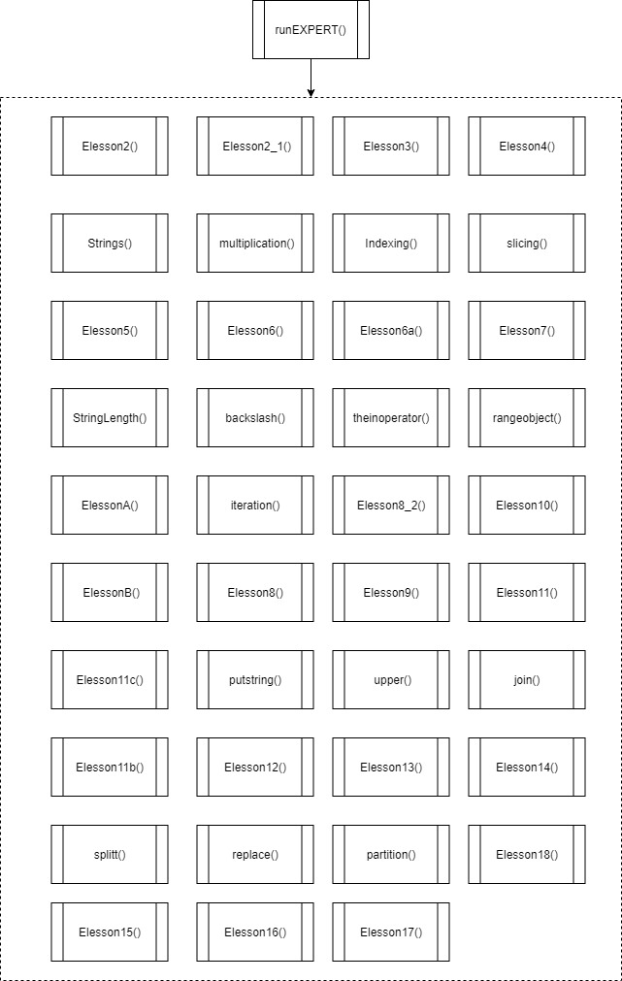

Fig.6 Hierarchy Chart part 4

The heirarchy chart shows the relationship between the functions in the program. The first function is the startIsPressed(), which has the startQuiz() and showResult(). The showResult() has the subfunctions of runBEGINNER(), runINTERMEDIATE(), and runEXPERT(). These subfunctions have their own functions that display various lessons in python programming.

Refer to the appendix for the detailed flowchart. The flowchart of the program provides the detailed events of the output. The program begins by importing Tkinter module and processing the "root", "root.title", "root.geometry", and "root.config" of the program. The python logo together with the text label of "Python Questionnaire" and the instruction were displayed in the first part of the program. There is also a click button for the user to press indicating that he or she is ready to take the assessment. There are 5 functions in the assessment part of the program such as "gen", "selected", "leave", "calc", and "enter". The modules of these functions contain a set of intructions for the program to follow. It includes displaying the survey questions, analying the results, and showing the result. The showresult(score) module is responsible for determining the result of the user's assessment. It will direct the user to runEXPERT function if score is greater than or equal to 31. It will direct the user to runINTERMEDIATE function if score is greater than or equal to 16 and score is less than 30. Otherwise, the program will lead the user to the runBEGINNER function. The runBEGINNER module contains various lessons such as printing text, data types, basic arithmetic, integer division, math module, variables, increments, functions, boolean operators, and comparison operators. The runINTERMEDIATE module discusses numpy and its application. The runEXPERT module contains sequences and iterations, strings, addition (concatenation), multiplication (repetition), indexing, slicing, string length, backslash, the in operator, range objects, list, indexing, heterogeneity, iteration, manipulating lists, tuple, raw strings, multiline strings with triple quotes, and useful string methods.

# Program features and screenshots

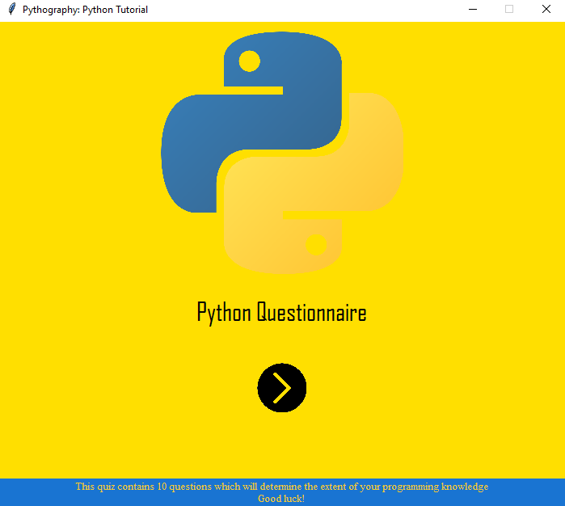

Fig. 7 Window for the assessment of the user’s level

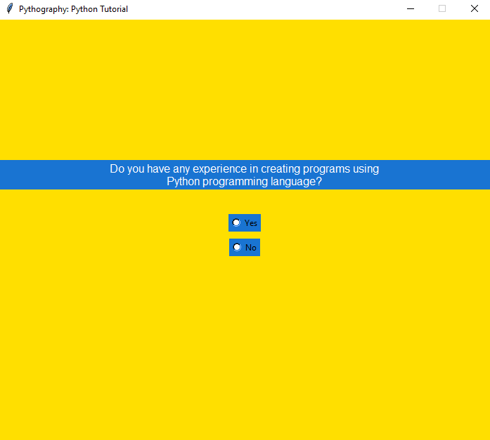

Fig. 8 Sample assessment question

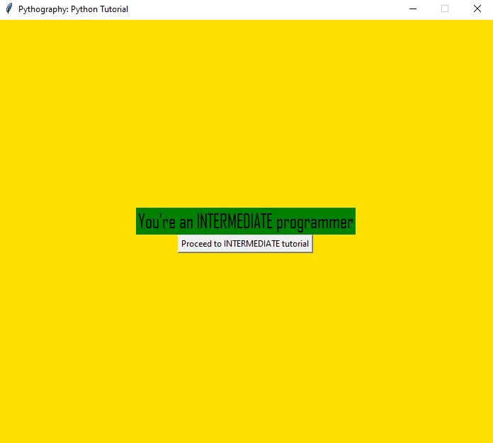

Fig. 9 Sample Assessment Message

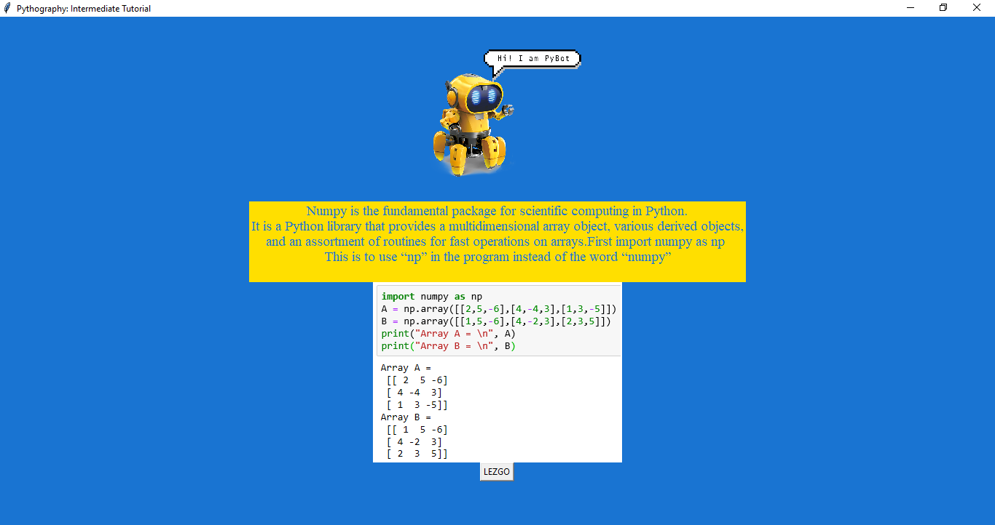

Fig. 10 Sample discussion

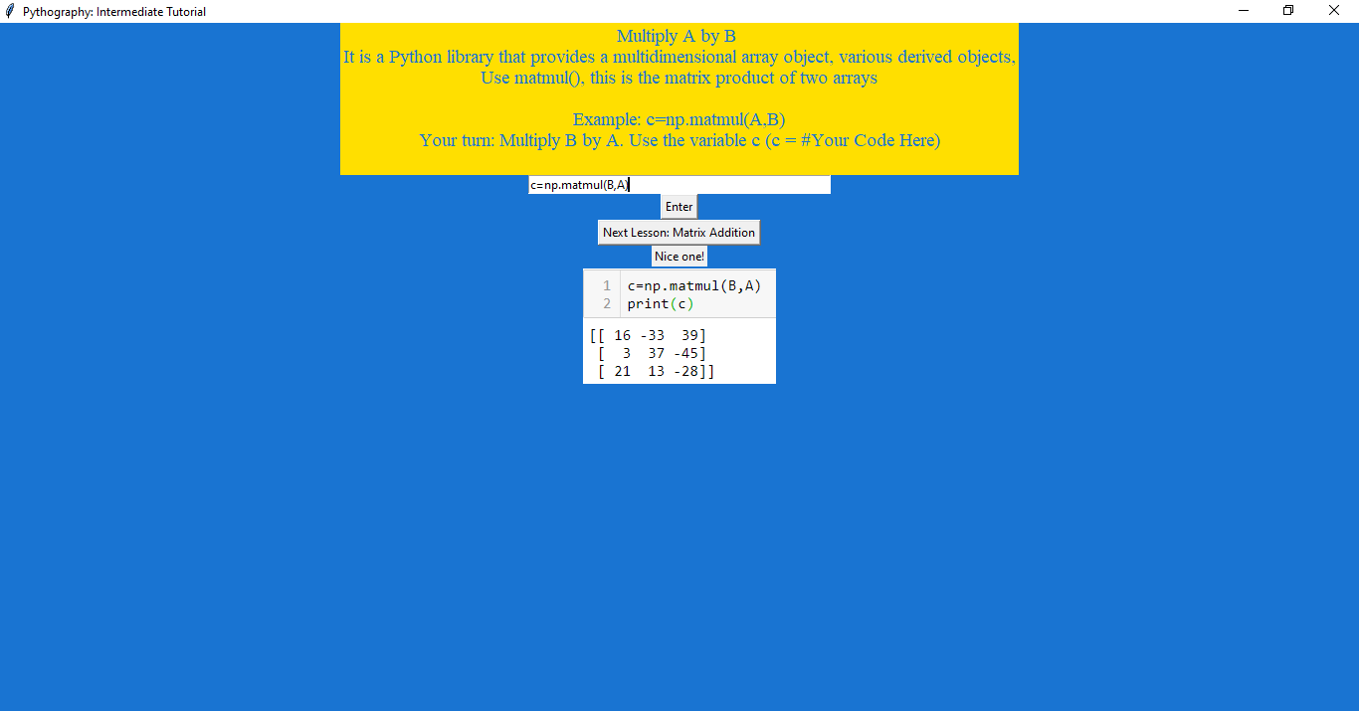

Fig. 11 Sample question after the discussion

# Conclusion and future improvements

Pythography, a program created through Tkinter was able to incorporate personalized learning in teaching Python Programming depending on the user’s assessed level (beginner, intermediate, and expert). Different sets of topics are offered to the user depending on the assessed level. These topics are discussed first followed by a question to test the understanding of the user regarding the topic discussed. The user can learn these topics at one’s own pace therefore promoting personalized learning.

Future related studies may add a pretest related to the topics to be discussed to properly assess the level of the user. It is also recommended to add a posttest to evaluate the level of improvement that the user was able to attain after using the program as well as to evaluate the program’s effectiveness. Lastly, it is suggested to design the program similar to a game in order to motivate the users to learn while having fun.

##### References

[1] N. Balog, “Why You Should Learn Python”

April 16, 2019, Available at: https://www.codingdojo.com/blog/why-you-should-learn-python

[2] J. Paul, “10 Reasons to Learn Python in 2018”,

Nov. 29, 2018, Available at: https://www.codingdojo.com/blog/why-you-should-learn-python

[3] J. Clarke, “Personalized Learning: Student-Designed

Pathways to High School Graduation,” 2013.

[4] E. Popescu, P. Trigano, and C. Badica, "eDalgo:

Designing Personalized Courseware for Teaching

Introductory Programming,"Faculty of Automation,

Computers and Electronics at University of Craiova,

Craiova, Romania, 2006.

[5] D.Nandigam, S.S. Tirumala, N.Baghaei,

"Personalized Learning: Current Status and

Potential," IC3e 2014 - 2014 IEEE Conference on e-

Learning, e-Management and e-Services. 10.1109/IC3e.2014.7081251,2014

[6] S.Johns, M. Wolking., n.d. The Core Four Of

Personalized Learning: The Elements You Need To

Succeed. [online] Edelements.com. Available at:

https://www.edelements.com/hubfs/Core_Four/Education_Elements_Core_Four_White_Paper.pdf

[7] B. Isong, "A Methodology for Teaching Computer

Programming: first year students' perspective,"

Department of Computer Science & Information Systems at University of Calabar, Thohoyandou, South Africa, 2014.

[8] Z. Jinghua, "A semantic web based personalized

learning service for programming course in e-

learning," 2011 International Conference on

Mechatronic Science, Electric Engineering and

Computer (MEC), Jilin, 2011, pp. 1563-1566.

[9] S. Chookaew, P. Panjaburee, D. Wanichsan and P.

Laosinchai, "A Personalized E-Learning

Environment to Promote Students’ Conceptual

Learning on Basic Computer Programming," Faculty

of Computer Science and Information Technology,

Rambhai Barni Rajabhat University, Thailand, 2013.

[10] V.C. Ahku and S. Panchoo.,“Implementing

Personalised Learning For Mixed Ability Students

For Computer Programming In A Learning

Environment. 2019 Conference on Next Generation

Computing Applications (NextComp), Next

Generation Computing Applications (NextComp),

2019 Conference On, 1–8., 2019,

https://doi.org/10.1109/NEXTCOMP.2019.8883447

[11] M. Ivanović, D. Mitrović, Z. Budimac, B. Vesin, and

L. Jerinić, “Different Roles of Agents in

Personalized Programming Learning Environment,”

Lecture Notes in Computer Science New Horizons

in Web Based Learning, pp. 161–170, 2014.

[12] M.F. Sanner, "PYTHON: A PROGRAMMING

LANGUAGE FOR SOFTWARE INTEGRATION

AND DEVELOPMENT,"submitted for publication.

INTERVIEW QUESTIONS:

1.Are you taking stem strand?

2.Would you take a computer-related course in college?

3. Are you interested in programming?

4.Did you have any programming classes in the past?

5. Did you find your programming classes difficult in the past?

6.Do you have any experience in creating programs using the Python programming language?

7. Did you find your past Python programming experience difficult?

8. Do you search online for codes?

9. Does watching online tutorials help you become a better programmer?

**Appendix**

